**Project Design Phase-II**

**Data Flow Diagram &User Stories**

|  |  |
| --- | --- |
| Date | 16 October 2022 |
| Team ID | **PNT2022TMID38674** |
| Project Name | **AI-based discourse for Banking Industry** |
| Maximum Marks | 4 Marks |

**Data Flow Diagrams:**

A Data Flow Diagram (DFD) is a traditional visual representation of the information flows within a system. A neat and clear DFD can depict the right amount of the system requirement graphically. It shows how data enters and leaves the system, what changes the information, and where data is stored.

**Example:** [**(Simplified)**](https://developer.ibm.com/patterns/visualize-unstructured-text/)

Example: DFD Level 0 (Industry Standard)

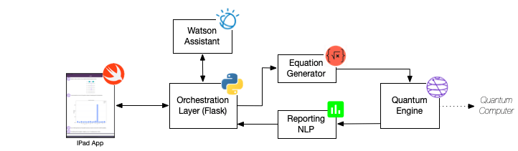

Database



**User Stories**

Use the below template to list all the user stories for the product.

| **User Type** | **Functional Requirement (Epic)** | **User Story Number** | **User Story / Task** | **Acceptance criteria** | **Priority** | **Release** |
| --- | --- | --- | --- | --- | --- | --- |
| Customer (Web user) | UI Design | USN-1 | As a user, I will view all icons,button,content | If the content will properly viewing in all devices. | High | Sprint-1 |
|  | Whatsapp integration | USN-2 | If a user use for this chatbot through this whatapp | If any greeting word can be given after it will help for you. | High | Sprint-2 |
|  | Text to speech | USN-3 | If a customer poor internet get so add phone integrate from chatbot. | If the option click to get the responses. | Low | Sprint-3 |
|  | messenger integration | USN-4 | If a user use for this chatbot through this messanger | If any greeting word can be given after it will help for you. | Medium | Sprint-4 |
| Customer (Mobile  user) | The functional  requirements are  same as a web  user | Same as a  Web user | Same as a web user | Same as a web user | High when  compared to  web users |  |